**GROUP-1**

**PERFORMANCE CHECK FOR DEALS OF THE WEEK MODULE OF URBANLADDER USING JMETER ON AWS**

* Create a Cloud Formation Template

[**https://aws.amazon.com/solutions/implementations/distributed-load-testing-on-aws/**](https://aws.amazon.com/solutions/implementations/distributed-load-testing-on-aws/)

* Specify template and stack details

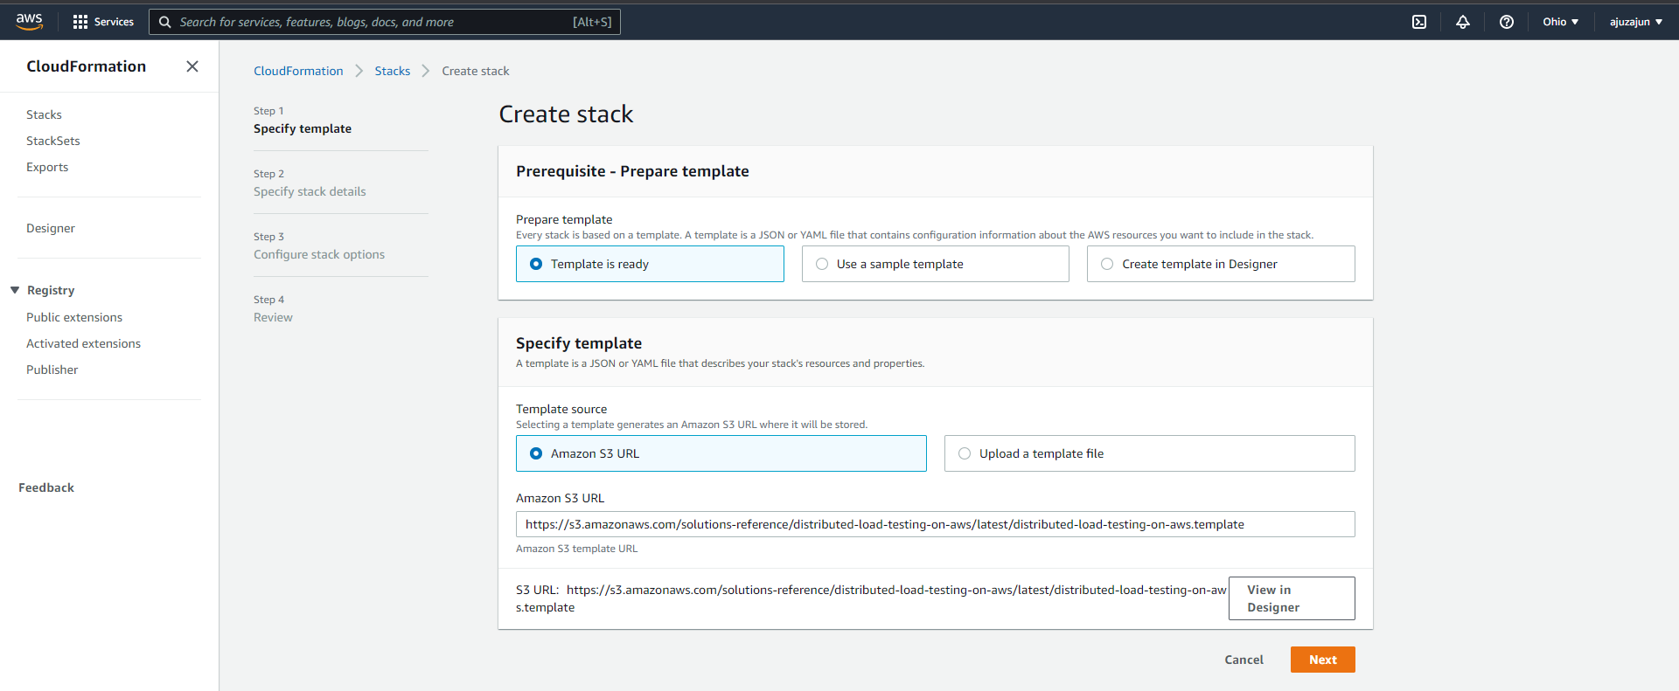

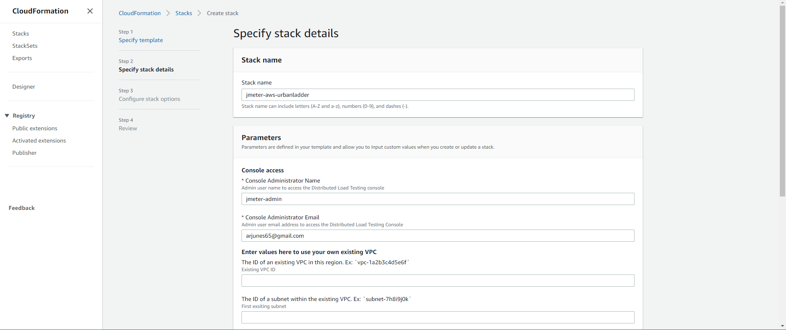

* Configure stack options

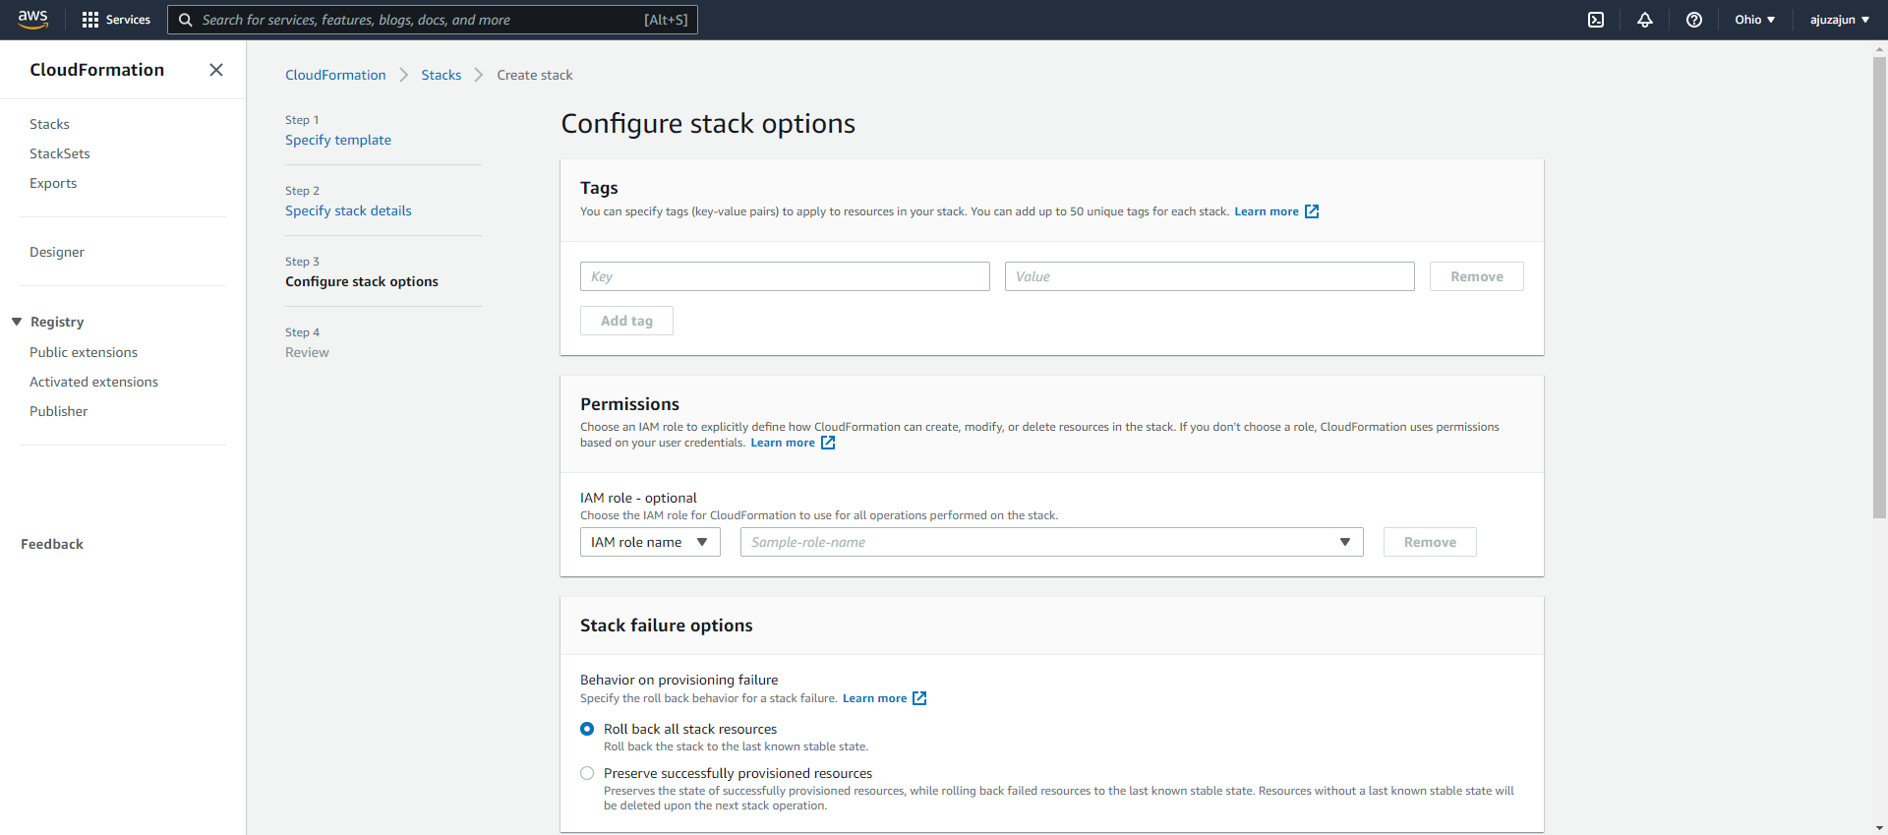blob:https://web.whatsapp.com/2950ace3-afd2-45d7-843a-8223dec85910

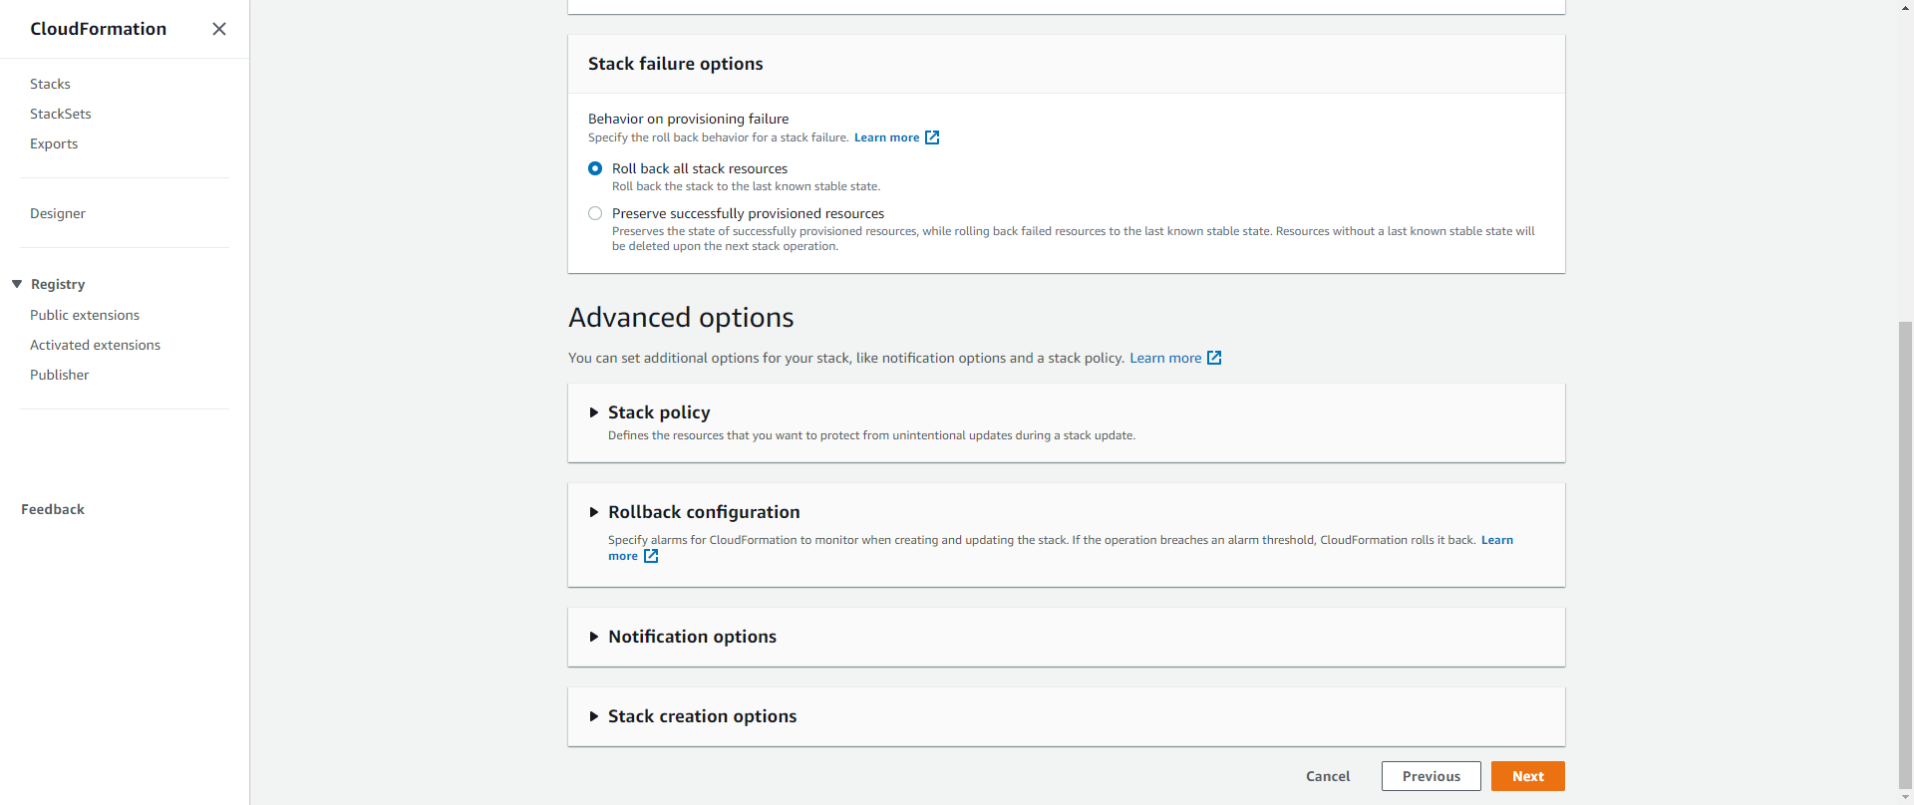

* Create the stack

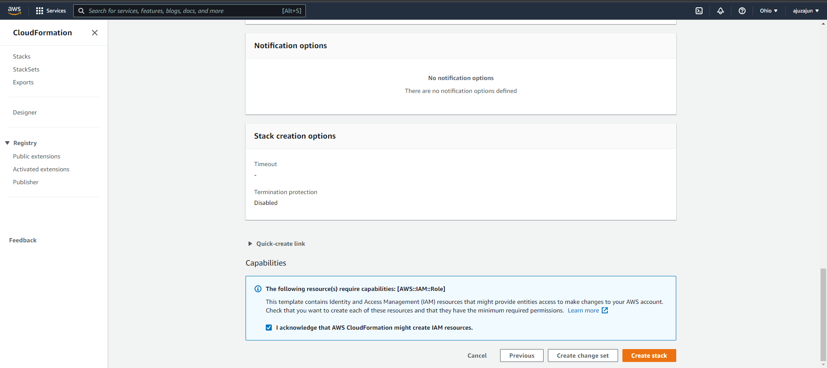

* After the stack got created login to jmeter console and you will get the credentials in the mail.

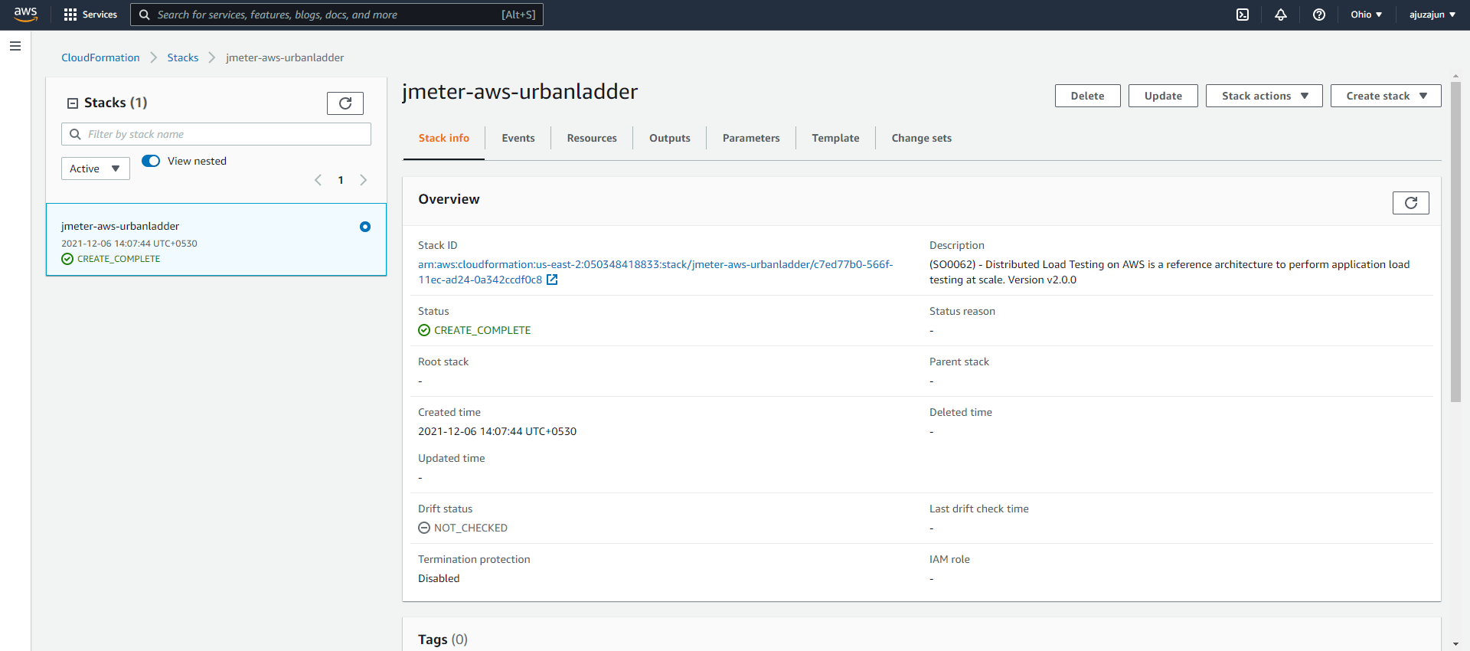

* Name the load test as Urbanladder and give the values.

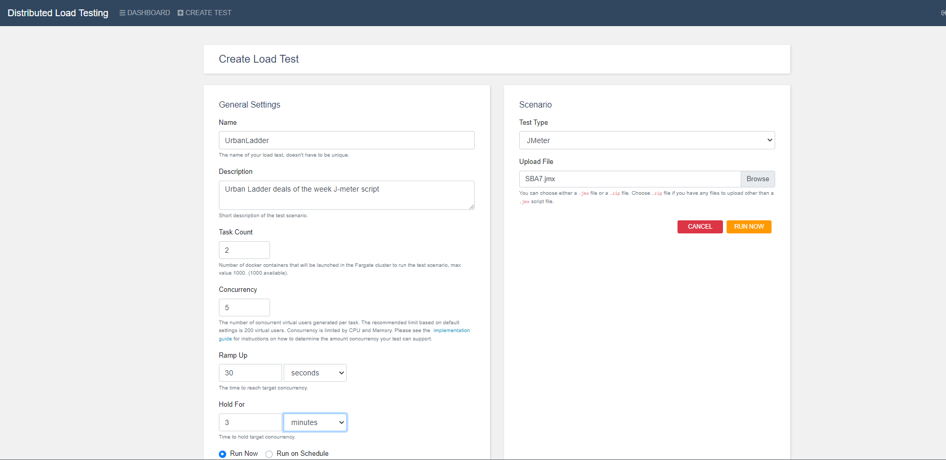

* In jmeter pass the server name and path at http request.

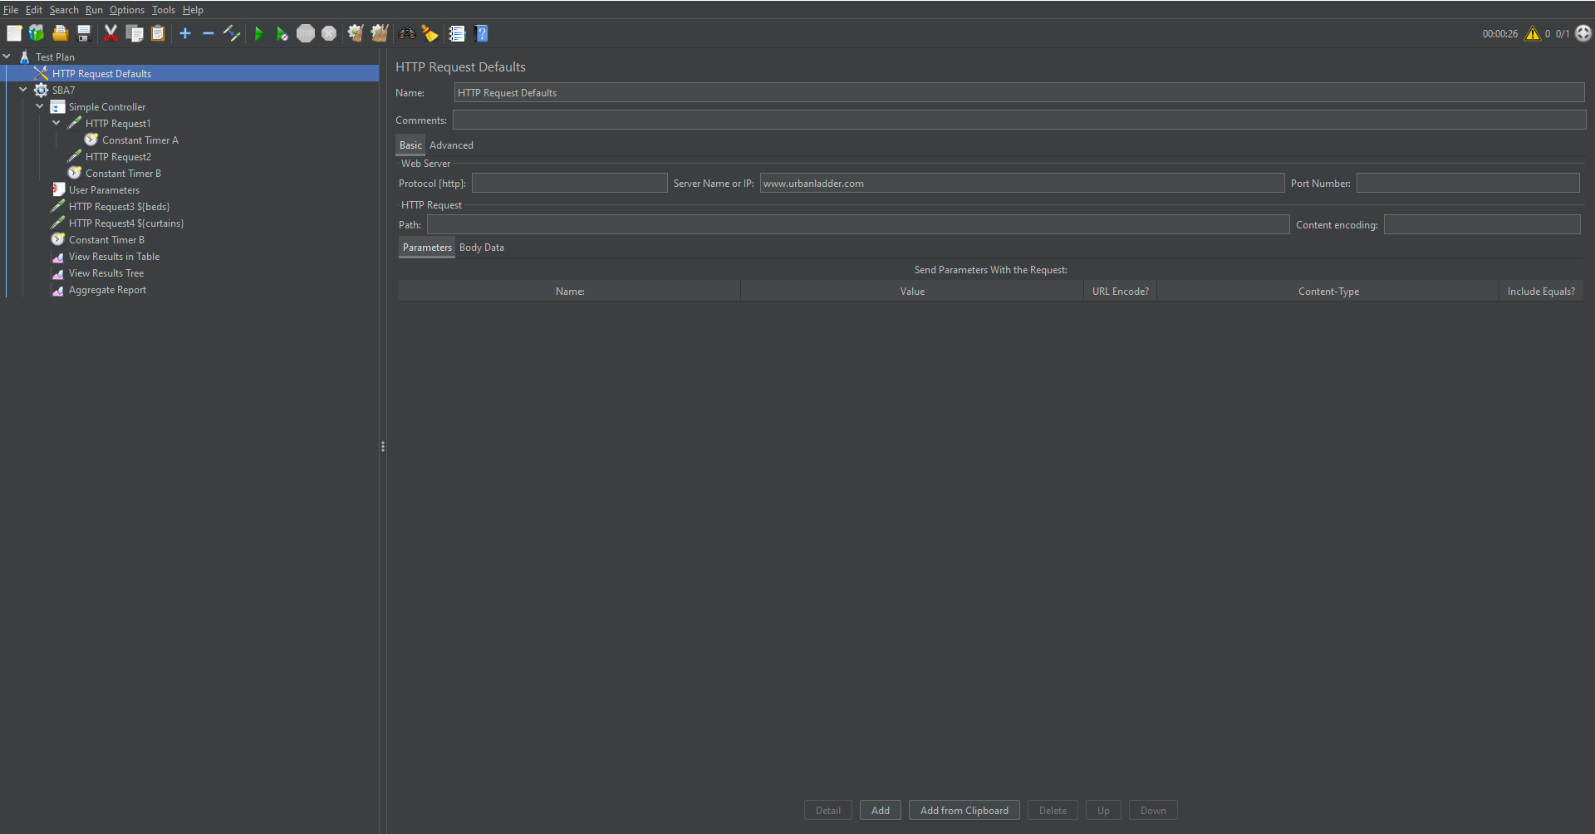

* Upload the JMX File in the loadtest console.



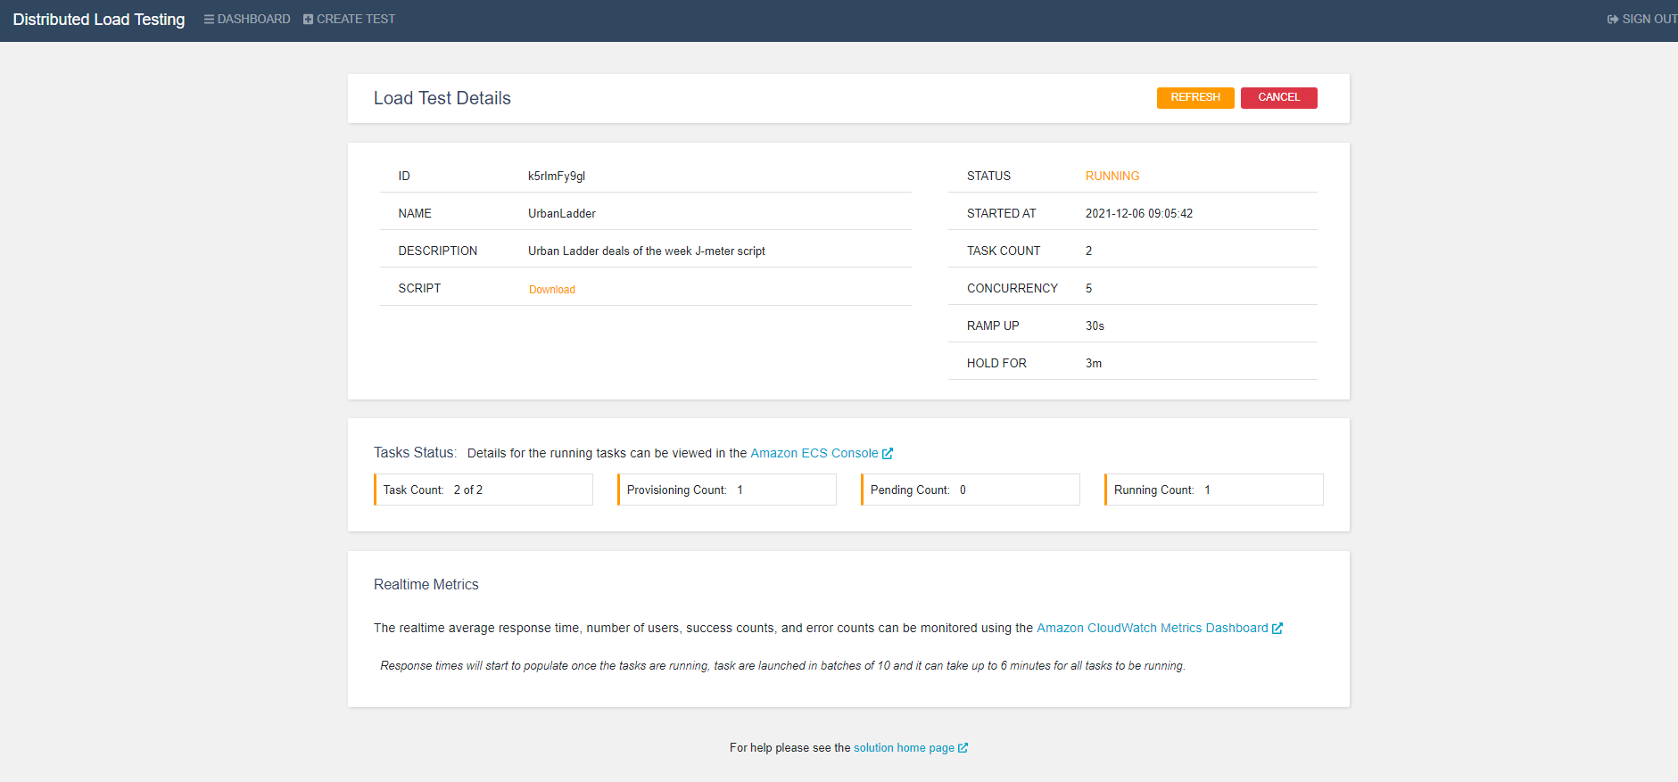

* Explore Ecs console and CloudWatch Metrics dashboard to explore more details about the test.

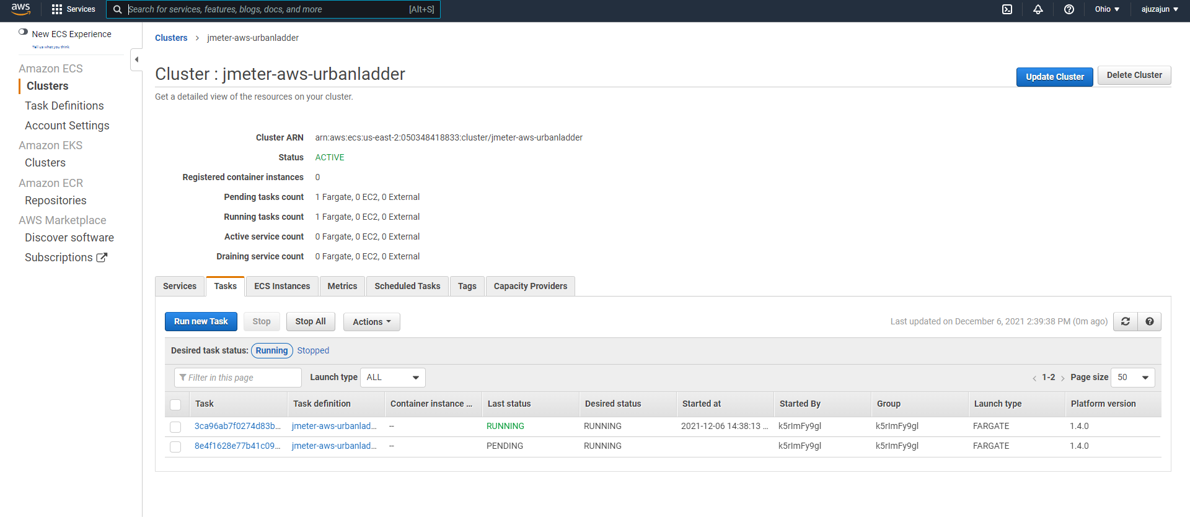

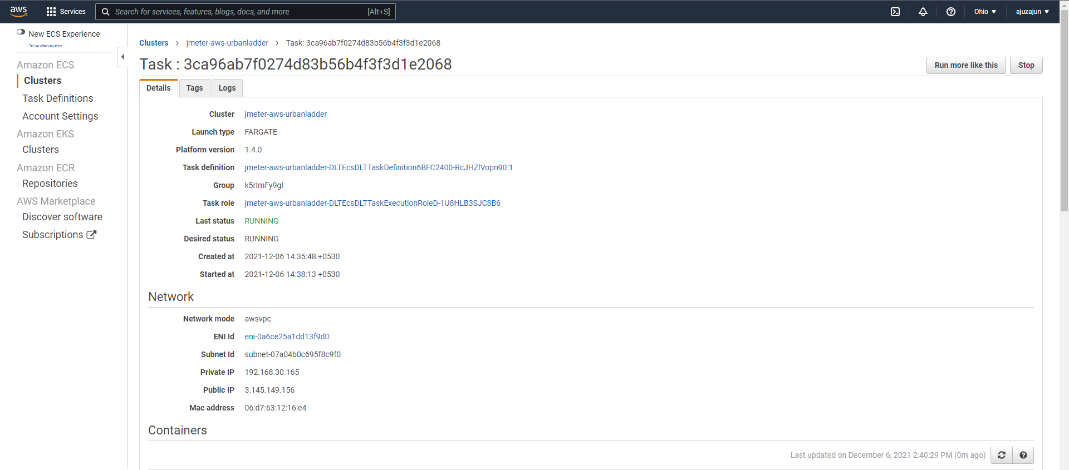

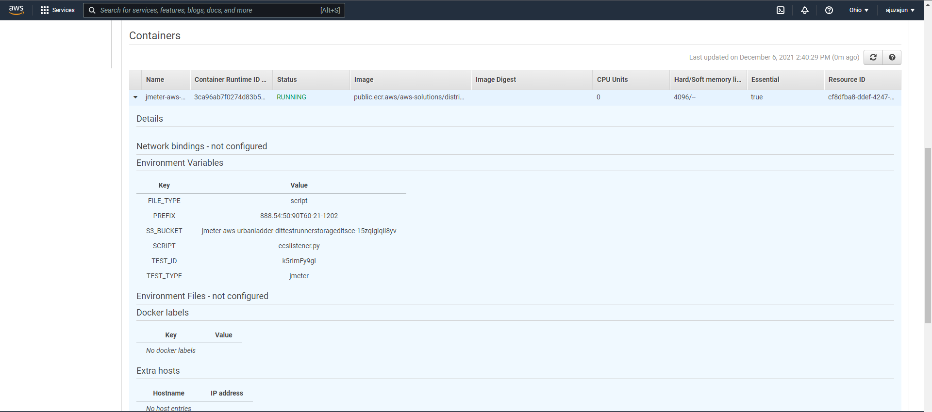

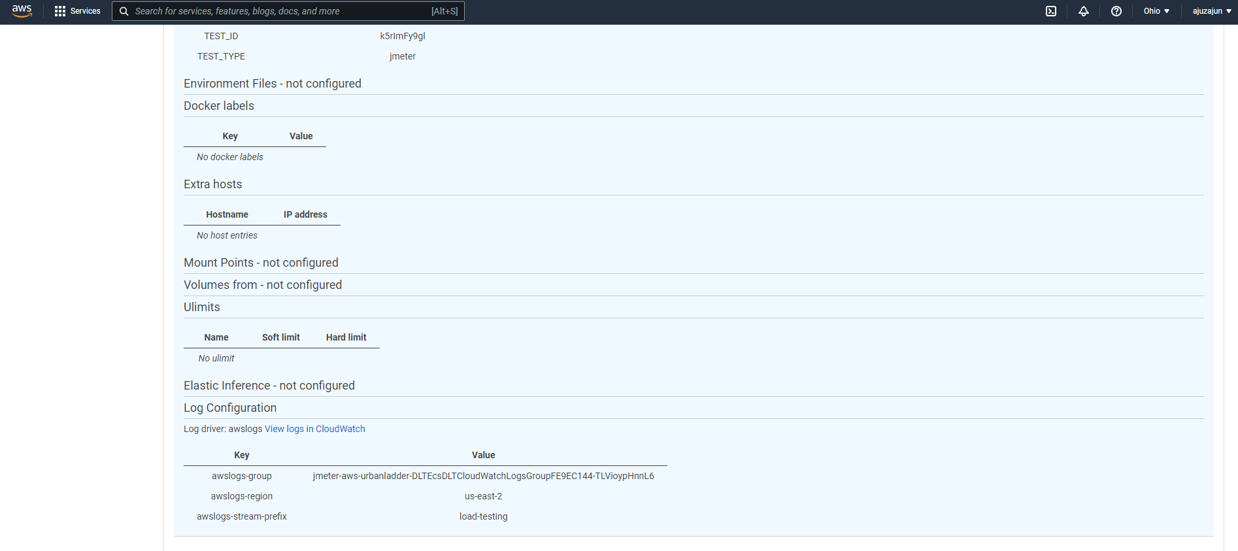

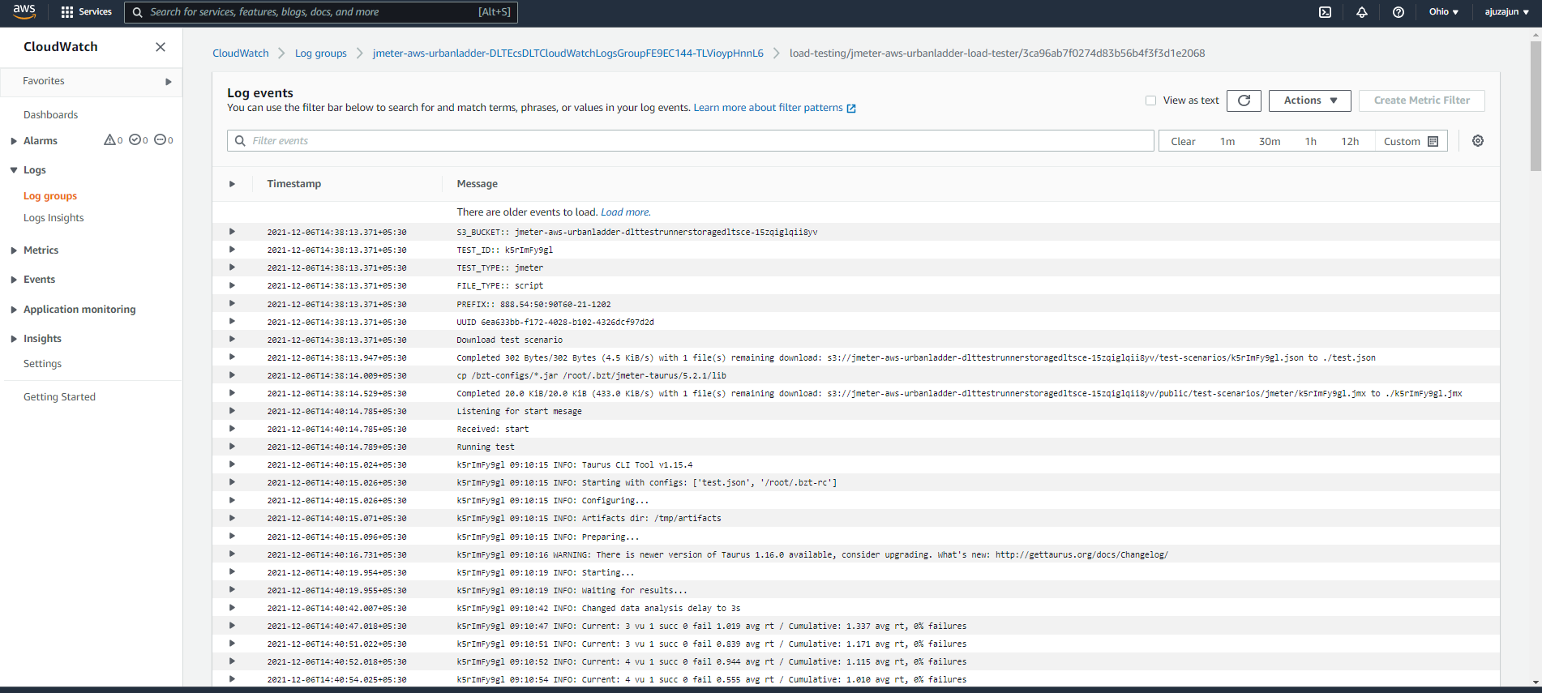

* To see the test result refresh the console.

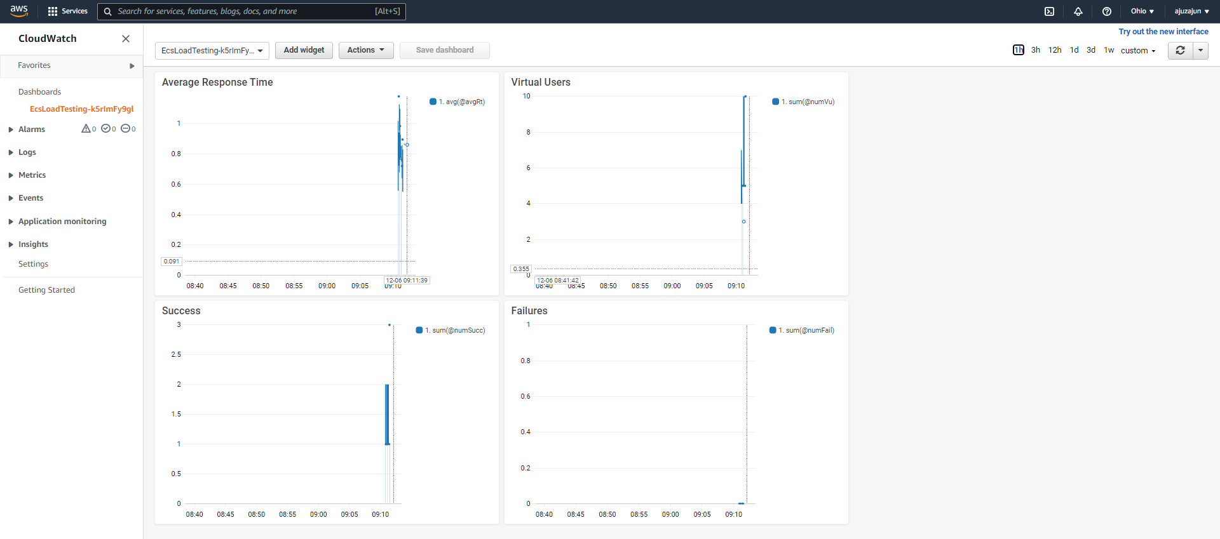

* Test results will be populated in the console of cloud watch metrics

